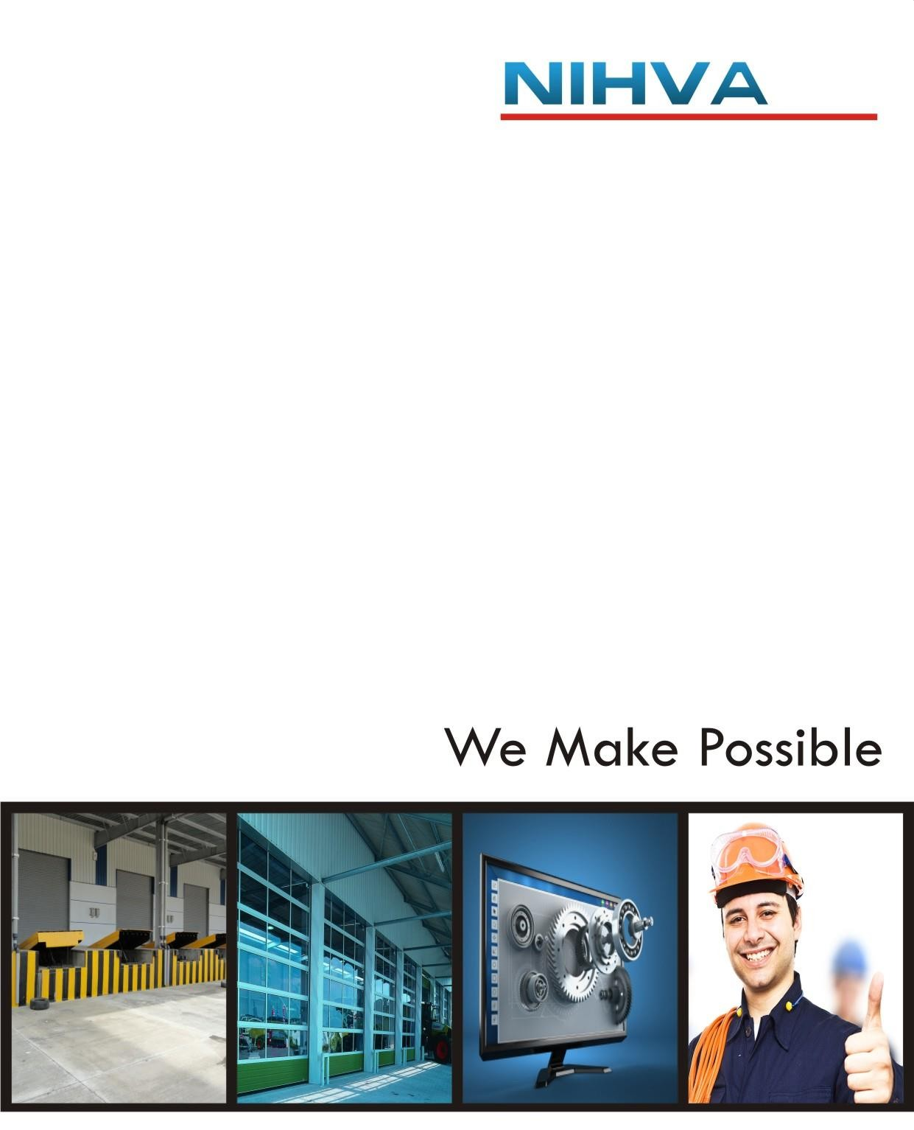


High Speed Door Operator (Operation instruction)

Industrial door operator operation instruction:

i WARNING

- This door machine must be installed and debugged by professional installer.

- Corresponding installation and wiring shall be in accordance with the Construction Criteria, and wires diameter 1.5 mm'. Ensure the power source has sound earth grinding, and the grinding wire shall tightly connect into grounding plate. Cutting away the grinding lead wire is prohibited. Earth leakage protection device fulfilling corresponding national criteria shall be firmly set at the front end of the inlet power source.

- This Industrial Door Machine is only applicable for door with sound balance and Spring-Balanced, or the Machine would likely be destroyed by overloading.

- The door shall run freely and without any seizure wear. Each end of the door rail shall have one restrictor or a buffer booster to avoid the door slipping from the guide rail.

- Control box shall be installed on wall or volume from where the door's operation condition can be visually observed, and with at least 1.4 meters distance above floor level so that children could no longer touch it. For the sake of children's safety, remoter shall be kept away from kids. Operating the door remoter at a place invisible of the door's running condition is prohibited.

- Electricity supply system of both door opening machine and control box shall be cut off if maintenance and removal required. Door shall be checked before maintenance and removal to ensure it is in lock-up condition and there is no any sign of falling risk.

- No any entrance or stay is allowed once the door is running.

- Pulling the hand chain of this machine is prohibited when the door machine is in operation, since it will easily damage the door.

- For equipment with shift clutches, pulling ropes of the shift clutches is prohibited unless otherwise the door is in definite close status, and no any other conditions are allowed for rope drawing.

- For the sake of safety of people and cars passing by, infrared safeguard device and gasbag preventative devices shall be available.

Content:

- parameter table 3
- High Speed Rolling Door Motor Installation 4
- Dial the code switch settings & Bearing mount diagram 5
- Circuit board structure 6
- Electronic Limit Connections and their Functions 7-8
- Port wiring instructions and their Operation 9-10
- Multi -functional port 11
- Display Settings button and display symbols 11
- Limit the debugging and parameter Settings 12
  - Limit debugging steps 12
  - P1 parameter debugging steps 12-13
  - P2 parameter debugging steps 13-14
  - P3 parameter debugging steps 14-15
- Function of remote control settings 15
- Circuit Board fault code : Reason and Solution 15
- Accessories list 16

Parameter Table:

1 | Type  (3*AC220V) | GYJ60 | GYJ80 | GYJ100 | GYJ180
2 | Rated Power | 800W | 1000W | 1500W | 2200W
3 | Starting Torque | 60N.m | 80N.m | 100N.m | 120N.m
4 | Reduction Ratio | 1:15 | 1:15 | 1:15 | 1:15
5 | No-Load Rotating Speed | 90r/min | 90r/min | 90r/min | 90r/min
6 | Type of lubricant | Oil Immerged
7 | Noise | ≤60dB
8 | Max Limiting Distance | Using the absolute value encoder electronics limited, output shaft to turn 20 laps
9 | Output Shaft Diameter | 25.4mm
10 | Use Environment | -20°C ~ 45°C
11 | Duty Cycle | S1
12 | IP Rating | IP65

Operator Size:

Sr.no | Part Name
1 | Outer shell
2 | Fan
3 | Electromagnet
4 | Handle
5 | Terminal
6 | Rectifier
7 | Encoder
8 | Reducer

High Speed Rolling Door Motor Installation:

Component no. | Component Name
1 | Soft roll gate
2 | Door pillar
3 | Side door fixed plate
4 | Mounting bracket (optional)
5 | Fast motor
6 | Slotting shaft
7 | Key
8 | Fixed ring
9 | Bolts and nuts
Installation Steps:
- Align Keyway on Motor with Keyway on Fabric Roll Shaft: One way of doing this would be by turning Motor using crank handle at bottom of motor until motor keyway aligns with fabric roll keyway. Roll Shaft should be out about 180 mm. (Door shaft diameter phi is 25 mm, keyway width of 8 mm.).
- Slide Motor onto shaft: Once key on shaft is aligned with keyway on motor side, Slide motor onto the shaft.
- Position Torque Arm Spacer: between the bearing plate and the Motor Torque Arm at hole provided.
- Insert Bolt: “M10X16” OR “M10X25” as per requirement for motor and mounting bracket and tighten them.
- Guide Fabric Roll: into upright channels by hand
Note: 1) Please do not try to install the motor on the right side if door was built for a left side motor door or vice versa, the door will not operate correctly.
2) Motor will not mount easily if keyway on motor is not aligned with keyway on fabric roll shaft.

Size of the fixed plate:

Bearing mount diagram:
- Pedestal Bearing UCFL206 (model) is used for smooth and continuous operation of the roiling shaft on which the fabric roll is mounted.
- The bearing makes sure that the rolling operation is smooth and uninterrupted due friction of shaft and the bearing plate/fixed side plate.

Dial the code switch settings: ► Electronic limit connection:
Port no. | Port Name | Wire Colour
1 | Power Supply (GND) | ° | Green Cable
2 | Communication port: RS485B | ° | Purple Cable
3 | Communication port: RS485A | ° | Purple Cable
4 | Power Supply: 5V DC VCC | ° | Red Cable

Rapid Door model
ON

1 2
Motor thermal protection - effective

Rapid Door model
ON

1 2
Motor thermal protection - invalid

Slippery rise door model
ON

1 2
Motor thermal protection - effective
Port no. | Port Name | Wire Colour
16 | Open the door limit (OP) | ° | Green Cable
17 | Public end: CO | ° | Purple Cable
18 | Close the door limit (CL) | ° | Red Cable

Slippery rise door model
ON

1 2
Motor thermal protection - effective

Mechanical limit connection:

UP

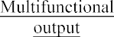

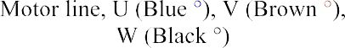
Electromagnetic Brake 97V DC
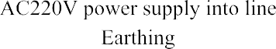
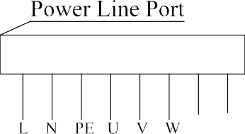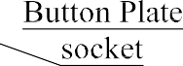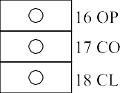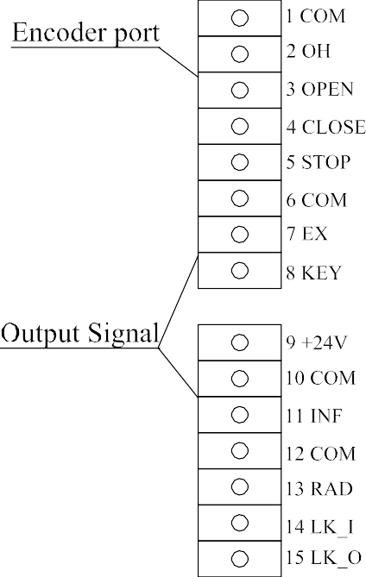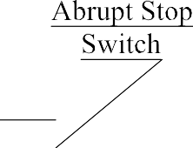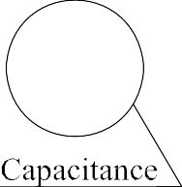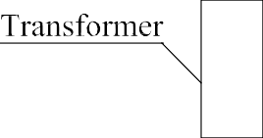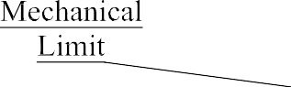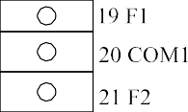
BL BN

Electronic limit connections & their functions:

Sr. No | Port no. on circuit | Code | Code name | Function of port
1 | 1 | GND | Grounding (Cathode) | Transfer excess electrical charges to a safe place
2 | 2 , 3 | A B | Communication port  for encoder | It provides asynchronous communication  between the Encoder ,Motor and PCB
3 | 4 | VCC | Voltage Common Collector (Anode) | It’s the power supply port for Encoder
4 | 1 | COM | Common (Public Port) | COM is common terminal for Motor with OH Port
5 | 2 | OH | Over Heating (Motor protection) | Stop the motor overheating when temperature <120°C).
6 | 3 | OPEN | Open | External Access Control port for OPEN command to the door.
7 | 4 | CLOSE | Close | External Access Control port for CLOSE command to the door.
8 | 5 | STOP | Stop | External Access Control port for STOP command to the door.
9 | 6 | COM | Common (Public Port) | COM is common terminal for  External Access Control
10 | 7 | EX | (Middle Limit) | External Access Control port for Half Opening Command to the door.
11 | 8 | KEY | Key  (Step and Step Function) | External Access Control Port for One Button Operation to OPEN > STOP >CLOSE and Vice-Versa

Sr. No | Port no. on circuit | Code | Code name | Function of port
12 | 9 | +24V | Power Output port | It’s a DC 24Vpower supply output port.
13 | 10 | COM | Common (Public Port) | COM is common terminal.  for power supply
14 | 11 | INF | Infra | The port to connect the safety sensors devices which works only when the door closing.  Normally Open (NO) Command
15 | 12 | COM | Common (Public Port) | COM is common terminal for INF,  RAD ,Interlocking
16 | 13 | RAD | Radar | Port to be connected to a Radar (similar to motion sensor with much higher frequencies)
17 | 14 | LK_I | Interlock input | an interlocking system is composed of two or more doors electronically connected so one cannot open until the other has closed. Using identification, you enter the first door which must close behind you before the second door opens and allows you to pass through.
18 | 15 | LK_O | Interlock output
19 | 16 | OP | Open | The port for External Mechanical Limit Switch for Open limit
20 | 17 | CO | Common (Public Port ) | COM is Common Terminal For OP/CL
21 | 18 | CL | Close | The port for External Mechanical Limit Switch for Close limit
22 | 19 | F1 | Multi-Function | Input for auxiliary devices. EXAMPLE: Buzzer, Light, Air Curtain, etc.
23 | 21 | F2 | Multi-Function
24 | 20 | COM | Common (Public Port) | COM is Common Terminal For Multifunction Port

Port wiring instruction and their operation:

- Motor Overheating Protection:
  - For protection of motor from overheating i.e above the calculated temperature of 120°C

    - Port 1- COM port.
    - Port 2 - OH port.
- External Three Buttons Function:
  - These three button outputs to be operated by three ports loop with a COM (port 6) are:
    - Port 3 – OPEN - External Access Control port for OPEN command to the door loop with
the COM (port 6)
    - Port 4 – CLOSE - External Access Control port for CLOSE command to the door loop with the
COM (port 6).
    - Port 5 – STOP - External Access Control port for STOP command to the door loop with the
COM (port 6)
  - NOTE: For all these operations to perform the Normally Open command is required.
- Middle Limit Function:
  - In this the door/gate automatically opens and sets in the middle limit position i.e it sets in the middle of the complete clear opening. This condition occurs in case of external emergencies, example: external fire signal, as the switch is pressed the door/gate automatically comes in its position due to two ports: -
    - Port 7 – EX – External Access Control port for Middle Limit / Half Open command to the door.

    - Port 6 – COM
- Step and Step function:
  - Single Button Operation for External Access Control port for OPEN >CLOSE> STOP command to the door and Vice-Versa.

  - Ports to operate the Step and Step function:
    - Port 8 – KEY – this is the port that brings the Step & Step function into operation with the
COM (Port 6)

- DC 24V power supply output function:
  - Here, voltage of DC 24V is achieved as power supply output.

    - Port 9 - +24V
    - Port 10 - COM
- Saftey Sensor Function:
  - This function is used to connect photocell / Infrared devices, example: Photocell infrared safety sensors, infrared alarm, etc.
  - As per requirements of an Infrared device it is connected via the DC +24V output power supply (port 9) or to a External device called SMPS, for required and proper power supply input.
  - The infrared / photocell device is connected to ports: -
    - Port 9 - DC +24V – these 2 ports give required proper power
Port 10 - COM supply to the Safety Sensor or Other devices
    - Port 11 – INF - these port are used to connect the safety sensor devices
Port 12 – COM (Normally Open Command) which works while closing the door.
- Radar Function:
  - This Function is for Radar connection, in case of a Door / Gate with high motion coverage area requirement Radar device is connected via this port:
    - Port 13 – RAD – this port is connected to the output device and is used to transfer signals to and from the Radar device with the COM (port 12)
- Interlock Function:
  - This Function is used where 2 or more controllers are connected to coordinate together in order to perform a required operation. Example: if controller A with Door/Gate A and controller B with Door/Gate B are connected together and an operation is performed where if Door/Gate A opens, the Door/Gate B remains closed & if B is opened, Door/Gate A remains closed. Like this many operations can be performed in coordination with 2 or more connected controllers with the help of these ports: -
    - Port 14 – LK_I (Interlock Input) – Input from other controller is receiver by this port.
    - Port 15 – LK_O (Interlock Output) - Output to other controller is sent by this port.
    - Port 12 – COM
COM 12 COM 12
RAD 13 RAD 13
LK_I 14 LK_I 14
LK_O 15 LK_O 15
Controller A Controller B

Multi-Functional port:
- This port is used for Auxiliary devices which are to be used while the door/Gate is in motion, example: buzzer and lights connected to this port get activated when the Door/Gate is in motion or performing any specific operation.
- When the Door/Gate comes into motion the relay which causes an output for the Auxiliary device to perform a specific task, example: a buzzer making sound.
- Port to Connect External Devices.
- Port 19 - F1 – Multi-Function port for Auxiliary device 1.
- Port 21 - F2 – Multi-Function port for Auxiliary device 2.
- Port 20 - COM1

Display Settings Button and Display symbols:
Open degree show Manual & Auto Closing
Sr.no | Parameter | Function
1 | LEARN | Learn Key
2 | ENTER | Confirm Key or Function into the key
3 | FWD | Up Key
4 | REV | Down Key,

Status Display
Input Status Display
XXX – X Digital Display Screen
LEARN

Learn

Enter
FWD

REV
FWD

ENTER REV
Input State
Digital Code | Code Instruction
1 | Stop
2 | Open
3 | Close
4 | Infra
5 | Radar
6 | One Key
7 | Middle Limit
8 | Interlock

Main menu: in normal working state the screen will display open degree, manual & automatic state, state of input.

- Opening Degree: It shows that, how much present the Door/Gate is opened or closed. “XXX” data changes between a range of 0-
100. Example: if the Door/gate stops in the middle of clear opening then the reading will “50” on digital screen.
- Manual & Auto Closing on display: Long press the REV button for more than 3 seconds & it will show the status (=): -
XXX X
XXX – X
Manual State Auto Closing Fuction

- Input Status “X”: it shows the current input signal digital code. Example: input digital code for “STOP” is “1” so “X” will show “1” on the screen

Page 11

Limit the Debugging and parameter settings:

Limit to learn
    - 1) Long press LEARN button more than 6 seconds - L0 reads on LED, (Upper limit)
    - 2) Press ENTER key - data feedback by the encoder can be read,
    - 3) Then keep holding down the FWD key (UP) until the door reaches the desired location,
    - 4) Press ENTER key to save the settings. At this time, limit to learn is over,
    - 5) When LED display reads L1 (that is the lower limit), (Down Limit)
    - 6) Press the ENTER key to access the data feedback by the encoder,
    - 7) Keep holding down the REV key (falling) until the door falls to the desired Location,
    - 8) And then press ENTER to save the settings;
    - 9) Symbol "L2" appears on the screen at the same time - can press FWD set limit, if you don't need to set up the middle spacing according to LEARN key to return to the main menu. (Middle Limit)
    - 10) At this time, limit to learn is over.

P1 parameter Settings:
    - 1) Under the main menu, press ENTER more than 3 seconds, the display shows P1,
    - 2) And then press ENTER in the display digital box, ENTER the password 1588. Now LEARN key for shift key (at this time, LEARN to digital shift keys, mobile digital cursor to Single digits, ten digits, thousand digits, and then with the FWD key respectively & REV adjust up and down all the data on the digits),
    - 3) Press ENTER - shows P1-01, (at this point by FWD key or REV key can choose need to adjust the parameters of the up and down),
    - 4) Continue to press the ENTER key, ENTER the corresponding parameter setting. At this time more than hundred-digit data adjustment need LEARN shift key. More than ten digits data adjustment need only, long press FWD or REV - data is automatically rapidly adjusted, loosen and then stop. Bits of data adjustment - only need single press FWD or REV adjust up and down.
    - 5) Other parameters adjustment method and so on, pay attention to the note that after the completion of each parameter is set, press ENTER to save. Then press LEARN step by step & after exit to the main menu, controller can start to work normally.

- P1 parameter name, scope, and the default value:

P1 Parameter: Password 1588
Number | Instruction | Parameter Range | Default Value
P1-01 | Open frequency | 10 – 99Hz | 70
P1-02 | Close frequency | 10 – 99Hz | 35
P1-03 | Buffer coefficient | 2---10 | 7
P1-04 | Closing Time Delay | 1----600 | 10
P1-05 | Torque increase | 0-15 | 10
P1-06 | Speed up time | 5 – 20 | 10
P1-07 | Deceleration time | 5---10 | 5
P1-08 | Multifunction Output F1 | 0 = Shut 1 = Close  2 = Open 3 = Running 4 = Wind Curtain 5 = Alarm | 0 = Shut
P1-09 | Open Point move/continuous move | 0 = continuous move; 1= point move | 0
P1-10 | Close Point move/continuous move | 0 = continuous move; 1= point move | 0
P1-11 | Interlock Function | 0=shut; 1=open | 0
P1-12 | Limit up Query | Limit Up Setting Data | Read-only
P1-13 | Limit Down Query | Limit Down Setting Data | Read-only
P1-14 | Middle Limit Query | Middle Limit Setting Data | Read-only
P1-15 | Point move frequency | 10 – 50Hz | 12
P1-16 | P1 Parameters (Restores the default value) | 1 = restore | 0

P2 parameter Settings:
- 1) Under the main menu, press ENTER more than 3 seconds, the display shows P1.
- 2), And then press "FWD" key or "REV", (display data can switch between P1, P2, P3).
- 3) Switch to the P2 parameters, and then press ENTER on the display digital box, ENTER the password 8851. Now LEARN key for shift key (at this time, LEARN to digital shift keys, mobile digital cursor to Single digits, ten digits, thousand digits, and then with the FWD key respectively & REV adjust up and down all the data on the digits)
- 4) Press ENTER - show P2-01, (at this point by FWD key or REV key can choose need to adjust the parameters of the up and down)
- 5) Continue to press the ENTER key. ENTER the corresponding parameter setting. At this time more than hundred digit data adjustment need LEARN shift key. More than ten digits data adjustment need only, long press FWD or REV - data is automatically rapidly adjusted, loosen and then stop. Bits of data adjustment, only need single press FWD or REV adjust up and down.
- 6) Other parameters adjustment method and so on, pay attention to the note that after the completion of each parameter is set, press ENTER to save. Then press LEARN step by step & after exit to the main menu, controller can start to work normally.

  - P2 parameter name, scope, and the default value：

P2 Parameter: Password 8851
Number | Instruction | Parameter Range | Default Value
P2-01 | Limit mode | 0 = encoder, 1 = mechanical | 0 = encoder
P2-02 | Up limit advance | 0 – 50 | 5
P2-03 | Down limit advance | 0 – 50 | 10
P2-04 | Open overshoot alarm | 10 – 200 | 100
P2-05 | Close overshoot alarm | 10 – 200 | 100
P2-06 | Infrared distance | 1 – 800 | 500
P2-07 | Current coefficient | 50% - 110% | 100%
P2-08 | Brake frequency | 5 – 10 | 8
P2-09 | Locked-Rotor Time | 10---70 | 70
P2-10 | Multifunction Output F2 | Same As P1 Parameter | 0
P2-11 | Mechanical limit buffer time | 5 – 15 | 5
P2-12 | Mechanical Limit Level | 0 = (NO) , 1 = (NC) | 0 = (NO)
P2-13 | Stop Level | 0 = (NO) , 1 = (NC) | 0 = (NO)
P2-14 | Infra Level | 0 = (NO) , 1 = (NC) | 0 = (NO)
P2-15 | Radar Level | 0 = (NO) , 1 = (NC) | 0 = (NO)
P2-16 | P2 Parameters  (Restores the default value) | 1 = restore | 0

P3 parameter Settings:
    - 1) Under the main menu, press ENTER more than 3 seconds, the display shows P1.
    - 2), And then press "FWD" key or "REV", (display data can switch between P1, P2, P3).
    - 3) Switch to the P3 parameters, and then press ENTER on the display digital box, ENTER the password 00000. Now LEARN key for shift key (at this time, LEARN to digital shift keys, mobile digital cursor to Single digits, ten digits, thousand digits, and then with the FWD key respectively & REV adjust up and down all the data on the digits)
    - 4) Press ENTER - show P3-01, (at this point by FWD key or REV key can choose need to adjust the parameters of the up and down)
    - 5) Continue to press the ENTER key. ENTER the corresponding parameter setting. At this time more than hundred digit data adjustment need LEARN shift key. More than ten digits data adjustment need only, long press FWD or REV - data is automatically rapidly adjusted, loosen and then stop. Bits of data adjustment, only need single press FWD or REV adjust up and down.
    - 6) Other parameters adjustment method and so on, pay attention to the note that after the completion of each parameter is set, press ENTER to save. Then press LEARN step by step & after exit to the main menu, controller can start to work normally.

      - P3 parameter name, scope, and the default value：

P3 Parameter: Password 00000
Number | Instruction | Parameter Range | Default Value
P3-01 | Change Password | 0---99999 | 00000
P3-02 | Run Time Settings (Days) | 0---99999 | 99999
P3-03 | Run Time Settings (number) | 0---99999 | 99999
P3-04 | View the total elapsed time (Days) | 0---99999 | Current Time
P3-05 | View the running number | 0---99999 | Current Number
P3-06 | View the running number (The number of more than ten thousand shows) | 0---99999 | Current Number
5. The function of remote control Setting:
- Remote control receiving plate, installed on the screen of the socket on the back of the circuit board & can plug.
- Pay attention to the direction of the insert as well as when installation should pay attention in rectangle area specified by the circuit board.
Step 1: after electrify, hold the remote control receiver plate on white button until the red light is extinguished, to remove the original password.
Step 2: to press the white key learning, find loosen the red indicator into the learning state. Step 3: Press any one transmitter, find the red light is put out after two flashes, end of the learning process
Circuit Board Fault Code: Reason and Solution:

Sr.no | Error code | Instructions | The reason for the error analysis
1 | ERR01 | Power supply lacks | Three-phase 380 v lack of L2 phase
2 | ERR02 | Encoder not connected | Encoder cables
3 | ERR03 | Limit anomaly | Limit not set or limit beyond the set value
4 | ERR04 | Electrical short circuit | Motor cables short circuit or power up too much
5 | ERR05 | Motor overload | Motor current is more than set value
6 | ERR06 | More than life | Reset run times or run number
7 | ERR07 | Motor blocked | Lack of motor torque (Press ENTER reset)
8 | ERR09 | Motor heat protection | Waiting for the motor cooling
9 | ERR10 | Small door abnormal | Check the wiring or replace the switch
10 | ERR11 | Frequency conversion board overheating | Inverter overheating protection

Accessories List:

Electric Control List
Number | Name | Quantity | Note
1 | Electric control | 1 | standard
2 | Remote control | 2 | optional
3 | Chassis key | 2 | standard

Motor List
Number | Name | Quantity | Note
1 | Motor | 1 | standard
2 | Install the plate | 1 | standard
3 | fixed ring | 2 | standard
4 | key | 1 | standard
5 | Hex bolt M10X20 | 4 | standard
6 | Cable | 1 | standard (4x0.75x4m)
7 | Shield Cable | 1 | standard (4x0.3x4m)
8 | Cable | 1 | standard (2x0.75x4m)
9 | Brake wrench | 1 | Standard
10 | Shake the handle | 1 | standard




sales@nihva.com
NIHVA TECHNOLOGIES PVT. LTD.
Head Office: 187, G-Block, 1st Floor, Thermax Chowk,
MIDC, Above Kotak and Saraswat Bank, Chinchwad
Pune - 411019
+91 2066 3040 33
+91 85 51091 333
www.nihva.com
www.shivaah.com

